Case Glanc_1
History: Normal Volunteer
Sample Images:
Figure 1A: Ultrasound Midline sagittal view with pubic symphysis (PS), urethra, vagina, anorectum aligned.
Figure 1B: Corresponding schematic
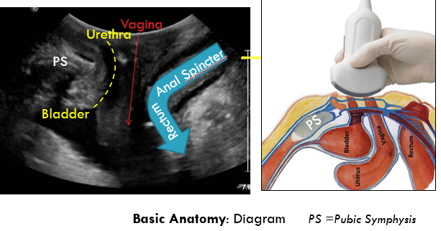
Figure 2: 3D acquisition with multiplanar acquisition and rendered view (normal) Pink arrows demonstrate placement of render box from mid-pubic symphysis to ano-rectal angle.

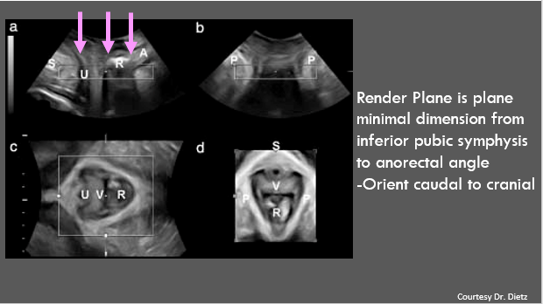

Figure 3: Rendered View – Normal anatomy
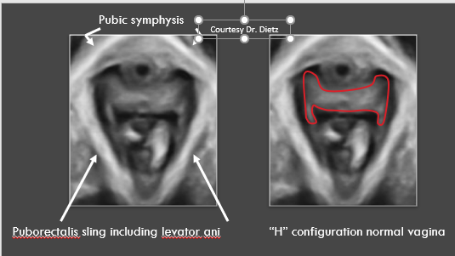

Additional Images provided: Online
Figure 4 Sagittal midline static image, no annotation.
Figure 5 Sagittal cine loop right to left
Figure 6 Coronal cine loop anterior to posterior
Figure 7 Sagittal cine loop with strain _midline (Uploaded)
Figure 8 Multipleanar reformats with rendered image
A, Rendered image
B, Tomographic or volume slicing through the Cplane ( axial)
Imaging Findings: None specific
Teaching Points/Tips: Easiest to begin with normal anatomy. If you are unfamiliar with the pelvic floor anatomy while searching for periurethral pathology or on the way to inserting a transvaginal probe, look around at the surrounding anatomy to gain comfort with the appearance of the normal anatomy.
Discussion: Us of the pelvic floor performed transperineal or translabial is simple and quick assessment of the pelvic floor for multicompartmental pathology. 3D additional views are important in particular for the following situations: 3D measurements urogenital hiatus, mesh complications, levator ani avulsion.
Diagnosis: Normal study
Figure 8 or Appendix #1: Sample Templates for Technique, Reporting. Please review as interested.
CASE: Glanc_2
Question: What is your Diagnosis?
History: Leaking urine with laughing, coughing.
Case 2_ Figure 1: Unlabeled Rest Figure 2 Unlabeled Strain
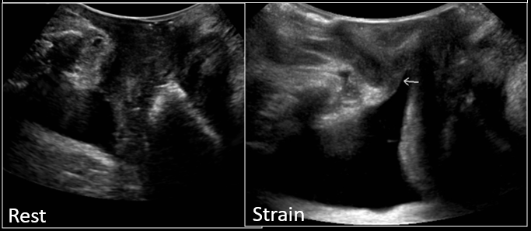

Same as above with labels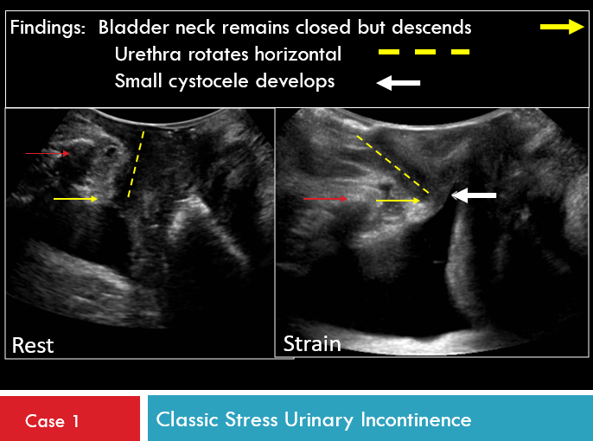

Same as above with labels
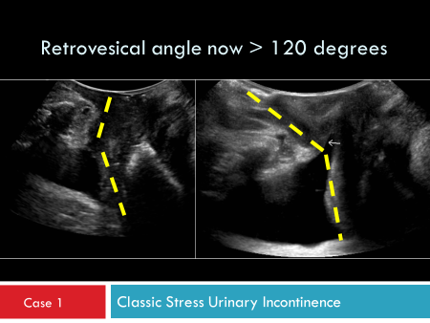

Case 2_ Figure 3 Companion Case: Cineloop of strain maneuver available
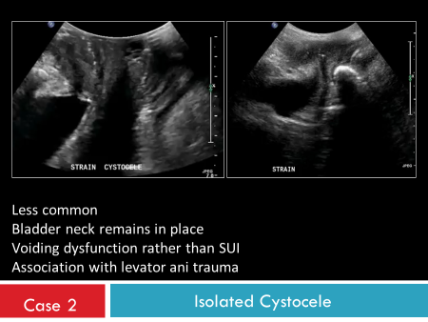
Discussion: 3 types of incontinence. The commonest is stress urinary incontinence (SUI), followed by urge incontinence and then overflow incontinence.
Stress urinary incontinence (SUI) is the unintentional loss of urine, typically occurs when increased intrabdominal pressure associated with coughing, sneezing, running, heavy lifting. Risk factors include childbirth (vaginal route especially prolonged second stage labor) and age. Other risk factors include chronic cough/sneeze, elevated BMI/obesity, high impact activities such as running/jumping over many years, chronic increased intrabdominal pressure as in weight-lifting. Connective tissue disorders, hysterectomy. Urge incontinence is associated with damage to the innervation or muscles of the bladder with symptoms of sudden intense urge to urinate, even with relatively empty bladder. Overflow incontinence associated with issues emptying the bladder.
Cystocele (prolapsed bladder) occurs when bladder bulges into bladder due weak or detached muscle/fascia/tendons/connective tissues between bladder and vagina.
- Midline defect : Cystocele caused by overstretching vaginal wall.
- Paravaginal defect: Separation vaginal connective tissue at arcus tendinous fascia pelvis.
- Transverse defect: pubocervical fascia at apex vagina is detached
Clinical: International Continence Society (ICS) pelvic organ prolapse quantification (POP-Q) defines anterior vaginal wall prolapse/cystocele as descent anterior vagina such that the urethrovesical junction (defined as >3cm proximal to external urinary meatus).
Imaging: Green classification based on degree retrovesical angle on maximal Valsalva and urethral rotation
Type 1: Cystocele with retrovesical angle ≥ 140 degrees & urethral rotation < 45 degrees.
Type 2: Cystocele with retrovesical angle ≥ 140 degrees & urethral rotation 45 - 120 degrees
- Associated SUI and intact levator ani
- Typically bladder neck descends with prolapsing cystocele (cystourethrocele), urethra often assumes horizontal orientation.
Type 3: Cystocele with intact retrovesical angle < 140 degrees. The bladder neck does not descend.
- Associated with levator ani trauma
- Present voiding dysfunction, likely related to urethral kinking.
Teaching Points/Tips:
- When a cystocele or pelvic organ prolapse occurs do not want transducer so tightly apposed to the perineum that it inhibitis the prolapse, thus imaging in real-time as the organs descend you can slowly lighten pressure on perineum.
- Assess degree of urethral rotation, look at proximal urethra.
- Report the following: strain maneuver:
- Development of cystocele and or cystourethrocele ( bladder neck descend)
- Bladder neck opens/funnel.
- Urethral mobility/rotation
- Retrovesical angle
Important to distinguish Type 2 vs 3 as treatment differs.

Management: Voiding Dysfunction, in particular SUI
- Lifestyle modifications: Weight loss, reduce fluid consumption
- Conservative: pelvic floor muscle (Kegel) excercises, vaginal weighted cones, biofeedback, bladder training, topic vaginal estrogen, continence pessaries
- Surgery typically midurethral sling

CASE: Glanc_3
Question: What is your diagnosis?
History: Pelvic Pressure, constipation.
Figures: A-D (cine loops available)
A, Anterior Compartment Rest B, Anterior compartment with strain
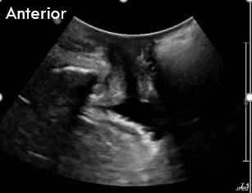

C, Posterior compartment mild strain D, Posterior compartment maximum strain
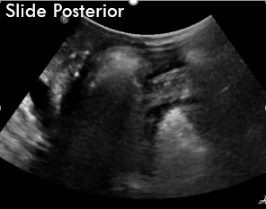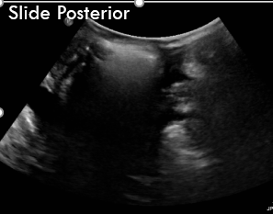

Discussion Findings:
Image A: Standard sagittal midline image oriented to anterior compartment.

Image B: Standard sagittal midline image oriented to anterior compartment. Note bladder neck dilates but does not descend.
Image C: Sagittal midline image with transducer moved posterior on perineum to include the posterior compartment. With mild strain small rectocele develops, note continuity muscularis propria layer confirming the bowel originates from herniation of anterior wall rectum.
Image D: Sagittal midline image with transducer moved posterior on perineum to include the posterior compartment. With additional strain effort a larger rectocele develops and descends to perineum.
Image E: Sagittal Cine Loop from anterior ( online only) aspect directed to posterior compartment demonstrates rectocele.
Image F: Sagittal cineloops from posterior aspect ( online only) redemonstrates rectocele
Discussion: Rectocele is due to a posterior rectovaginal fascial defect that results in anterior protrusion of the rectum. Risk factors are same as for general pelvic organ prolapse with most common risk factors for any form of vaginal prolapse is vaginal childbirth, advancing age followed by elevated BMI, chronic causes increased intra-abdominal pressure, connective tissue disease. Clinical symptoms include splinting, pelvic pressure, sexual dysfunction, fecal incontinence, defecatory dysfunction. The diagnosis is typically performed via clinical inspection with speculum used elevate anterior wall vagina to reduce uterine/apical prolapse and then patient asked to perform strain manoevre ( Valsalva or cough). Initial treatment is conservative: Dietary modifications, fiber, laxatives although more advanced stages are unlikely to regress; pelvic floor muscle training may be effective for incontinence but its role in prolapse is less clear; pessary; surgical approach (Apical suspension procedures, such as sacral colpopexy or iliococcygeus fascia suspension, may be required in addition to traditional colporrhaphy and site-specific repair)
Teaching Points/Tips:
- Anal incontinence commonly occurs with rectocele as share similar risk factors.
- Posterior wall defect may compress urethra masking stress urinary incontinence
- Poor correlation between MR image prolapse and clinical symptoms.

Diagnosis: Moderate rectocele which protrudes anteriorly through rectovaginal fascia and descends to perineum.

CASE: Glanc_4
Question: What is your diagnosis?
History: Pelvic Pressure
Figure 1: At Rest Figure 2 Valsalva
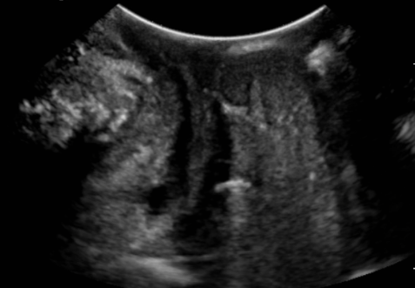

Figure 1: Midline sagittal image at Rest.
Figure 2: Midline sagittal image during strain maneuver.
Figure 3: Online only. Midline sagittal cine loop during strain maneovre. With Valsalva maneuver bowel prolapses between the vagina and the rectum, the incomplete haustrations identify it as colon, in real time can follow the descent from the abdomen. In real time can also identify rectum as separate from the bowel herniation.

Discussion: Sigmoidocele occurs when the sigmoid colon descends or prolapses into the lower pelvic cavity between the vagina and rectum. If large enough it may result in obstruction of the rectum resulting in symptoms of obstructed defecation or sensation of an inability to empty.
Management will depend on severity of the constipation, degree of prolapse and sigmoid redundancy. Thus options include sigmoid resection or sigmoidopexy. As intussception and rectal prolapse may co-exist, surgical management may be ventral rectopexy
Teaching Points/Tip: Important to determine if this is an isolated condition or associated with other conditions relating to pelvic floor dysfunction in order to optimize surgery choices.
Diagnosis: Sigmoidocele

CASE: Glanc_5:
Question: What is your diagnosis?
History: G3P2 55-year-old with a history of prolonged second stage of labor. Complains of pelvic pressure.
Figure 1: 3D Rendered image of the pelvic floor (Images courtesy Dr. Dietz)
Figure 2: 3D Rendered image of the pelvic floor ( Courtesy of Dr. Dietz) normal for comparison
Figure 3: MRI demonstrate normal levator ani insertion.
Figure 4: Schematic musculature pelvic floor in plane of rendered image ( axial)
Fig1 Fig 2

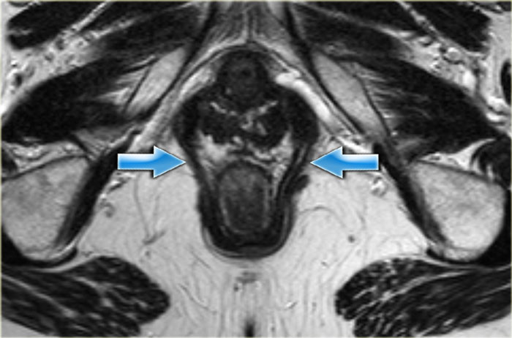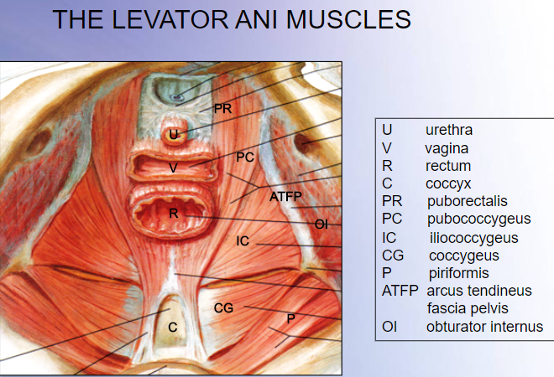
Figure 3 Figure 4

Image Discussion
Figure 1: Courtesy of Dr. Dietz. Rendered image pelvic floor ( axial) demonstrates on the left side (arrow) an avulsion of the levator ani muscle away from the pubic ramus, secondary sign is posterior displacement of left posterior vaginal fornix. The arrow on the right demonstrates the normal insertion of the levator ani on the inner medial surface of the pubic bone.
Figure 3-4 : Normal correlates.
Discussion: Avulsion levator ani can occur 13- 36% parous women, with risk increased with prolonged 2nd stage labor, forceps delivery, episiotomy or 3rd/4th degree tears. Levator avulsion is consdiered “macrotrauma” in which puboretalis component of the levator ani complex is detached from the inferior medial pubis ramus. Althugh the initial injury is occult, levator ani avulsion is associated with increased long-term risk of pelvic organ prolapse (POP) with vaginal birth the main modifiable risk factor for female, especially for cystocele and uterine prolapse. The urogenital hiatus is the largest natural hiatus in the body, thus if levator ani pulled off/avulsed off the pubic bone there is increased risk for pelvic organ prolapse with any increase in intrabdomimal pressure with estimates of 2x risk bladder prolapse, 3x risk uterine prolapse and increases risk of recurrent prolapse after pelvis floor surgery.
Diagnosis of levator ani avulsion identifies a group of patients at high risk of prolapse recurrence after surgery.
Teaching Point/Tip, Dr. Dietz has suggested that levator ani avulsion can also be diagnosed with the aid of tomographic slices of the volume in the Cplane ( axial) where the slice intervals are 2.5mm and the 3 central slices ( most central is the plane of minimal dimension) is abnormal indicateas complete avulsion whereas if any of the classic 8 slices are abnormal then it is a partial avulsion, for which clinical correlates are less definitive. Dietz HP, Bernardo MJ, Kirby A, Shek KL.. Int Urogynecol J 2011; 22: 699–704.

Management options include : Pelvic floor muscle training ( partial avulsion), bracing with intrabdominal pressure, early use of pessary, mesh. Typically treat symptomatic POP rather than the avulsion directly.
- Lowder JL, Ghetti C, Nikolajski C, et al. Body image perceptions in women with pelvic organ prolapse: a qualitative study. Am J Obstet Gynecol 2011; 204:441.e1.
- Sung VW, Washington B, Raker CA. Costs of ambulatory care related to female pelvic floor disorders in the United States. Am J Obstet Gynecol 2010; 202:483.e1.

Case: Glanc_6
History: Pressure. Status post hysterectomy.
Figures 1 Sagittal cine loop with strain
Imaging Findings: Strain demonstrates multicompartment prolapse with cystocele, enterocele, rectocele development.
reconstructive surgery ( widely variable results depending on type of prolapse and type of repair).
Discussion:
The pelvic organs are supported by continuous endopelvic fascia including:
- Uterosacral/cardinal ligaments suspends uterus and upper vagina to sacrum and lateral pelvis.
- The levator ani muscle and arcus tendinous fascia pelvis supports length vagina thus avulsion/interruption contributes to anterior vaginal wall prolapse – cystocele.
- Perineal body/membranes/muscules support distal 1/3 vagina thus disruption may cause urethral hypermobility/perineal descent/rectocele.

Pelvic organ prolapse (POP), the herniation of the pelvic organs to or beyond the vaginal walls, is a common condition. Symptoms may impact daily activities, sexual function, body image and exercise. Treatment of POP requires significant healthcare resources; the annual cost of ambulatory care of pelvic floor disorders in the United States from 2005 to 2006 was almost $300 million and surgical repair of prolapse was the most common inpatient procedure performed in women older than 70 years from 1979 to 2006. The health care impact of prolapse is likely to expand, based upon estimates of an increasing prevalence in the growing population of elderly women. This is an important modifiable
Mamagement: May be treated by synthetic mesh, transvaginal mesh kits and autologus grafts. Remains controversial however reasonable approach:
Average Risk for Recurrent Prolapse: native tissue reconstruction which have higher rates recurrent prolapse but does not have synethetic mesh complications, thus lower has lower overall reoperation rates.
High Risk for Recurrent Prolapse or failed reconstructive surgery: Synthetic mesh repair.
Multiple sites ( professional guidelines) regarding mesh placement and FDA resources.
FDA (2016) reclassified surgical mesh for transvagina POP repair as Class III or high risk device.

Diagnosis: Pelvic organ prolapse, multicompartmental.

Glanc Case 7

History: Rule out recurrent metastases, lung cancer.

Figure 1: Axial CT Images

Figure 2: Sagittal CT Images ( Online only)

Imaging Findings: The CT images demonstrate global pelvic floor prolapse.

Discussion: CT is not a method for pelvic floor dysfunction diagnosis, although it may be helpful in the diagnosis of associated post-operative infections and abscess collections. Nonetheless, when pelvic floor dysfunction is incidentally noted on CT it should be commented on in the report.

Teaching Point/Tip: note the intact pelvic floor musculature.

Glanc Case 8

History; Post suburethral sling insertion
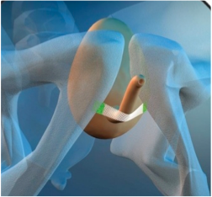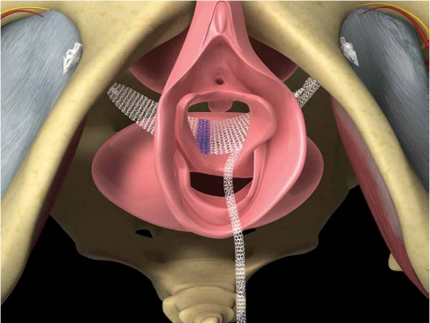
Tensionless vaginal Tape (TVT) Transobturator Tape (TOT)

Figure 1: 2D Cineloop Sagittal right to left
Figure 2: 2D Cine loop coronal anterior to posterior

Discussion:

Suburethral slings most commonly either TVT ( insertions medial pubic bone) with a tight “C” configuration or TOT (Transobturator). They are synthetic mesh which is placed posterior to the midurethra as believed continence maintained at this level rather than bladder neck, with incontinence related to failure of pubourethral ligaments thus resulting in stress urinary incontinence. The TOT may have an advantage in women who also have a levator ani avulsion.

When assessing mesh there are multiple features to look for:
- Sling location ( too high, too low)
- Sling mobility, fraying, deshiscence, erosion into adjacent structures.
- Measure in sagittal the pubic symphysis to sling gap
  - If > 15mm likely too big, thus ineffective.
  - If < 6-7 mm likely too tight thus may have voiding dysfunction which may be relieved by cutting the sling.

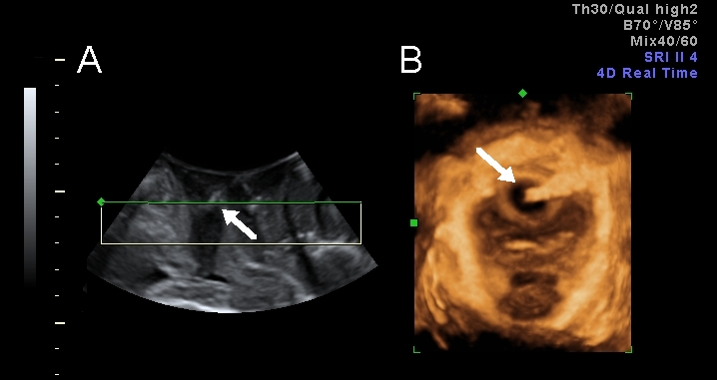

Case provided by Dr. HP Dietz for educational purposes. The white arrow points to the sling which on 3D rendered image clearly demonstrates erosion into the urethra.

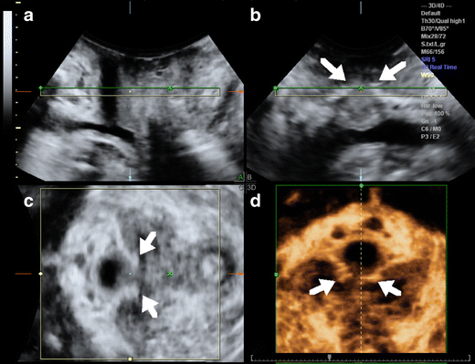

Case provided by Dr. HP Dietz for educational purposes. The white arrow demosntrates the surgically split mesh

Khatri Case 13_US

History: Incomplete bladder emptying, recurrent UTI, Small bladder capacity with frequency, urgency, nocturia.

Key Images:
Figure 13A Figure 13B
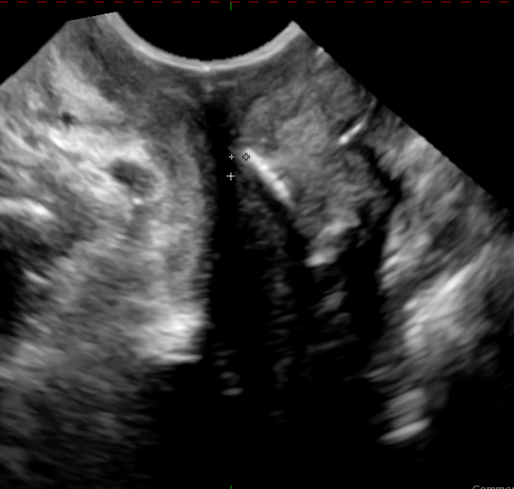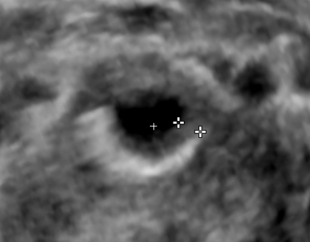

Figure 13C Figure 13D

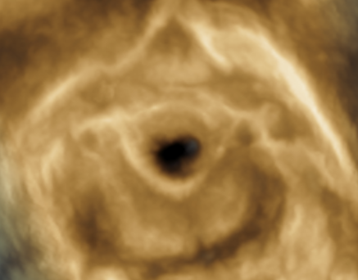

Imaging Findings:
Figure 13A: Sagital transperineal image: Demonstrates echogenic linear material in a mid suburethral location. On close analysis, the mesh is tilted at caudal aspect ( yellow arrow).
Figure 13B: Axial transperineal image ( multiplanar) demonstrates the suburethral sling is a TVT style mesh with the arm very tightly curved inward on right. ( Yellow arrow)
Figure 13C: Axial rendered image demonstrates same findings as Fig 13B.
Figure 13D: Voiding cystourethrogram demonstrates ballooning of the urethra proximal to the sling placement indicating component of obstruction related to sling, essentially “bladder outlet obstruction” on iatrogenic basis.

Teaching point(s) :

Discussion: This TVT sling on right side is very deep beneath mucosa of urethra . This can be appreciated in gray scale visually by its differential placement deeper into urethral muscular wall (A), tighter curve (B, C).
The patient underwent a transvaginal suburethral excision of deeply seated sling which required urethral wall reconstruction and primary vaginal wall closure.

Diagnosis

Notes

Khatri Case 16 US

Sample Templates
Imaging Protocol
General Instructions: Patient empties bladder prior to procedure. Patient on stretcher with water resistant pad placed beneath buttocks in dorsal lithotomy position. Patient preferentially in a partially upright position or sitting position to improve “straining” or Valsalva manoeuvres. Access to perineum may be improved by elevating patient hips or using gynecology stretcher. Probe is covered with gel followed then covered with a barrier (commercial plastic barrier or condom sheath) as per site infectious disease parameters. Utilize rectal type gel packets to minimize vaginal mucosal irritation. The probe is then placed transperineal ( translabial).

System Requirements for Pelvic Floor Ultrasound
- 2D ultrasound system with cine loop function, typically a 3-6 MHz curved array transducer
- 3D/4D system
  - Permit imaging axial plane (also called C-plane or rendered view plane)
    - Assess integrity of puborectalis muscle (3D), anterior mesh/slings
    - Assess urogenital hiatus (4D)
  - Systems designed for prenatal diagnosis are typically well suited
  - Typically want minimum 70-90 degree aperture with acquisition angle of at least 70 degrees to permit visualization of levator hiatus in real-time.

Probe Selection: Translabial or Transperineal access
Typically, convex probe with multifrequency range, generally in C5-1 range although higher frequency such as C4-8 may be useful. When available, a 3D probe is utilized with similar frequency ranges. On rare occasion a transvaginal probe may be required, follow usual preparation of probe.

Minimum Images Required:

A. At Rest
Sagittal or longitudinal images: (2D or 3D transducer)
1. Midline image with landmarks of pubis, urethra, vagina and anorectum junction.
2. Cine-loop capture from right across midline to left, to include from obturator foramen on both sides.
- Select static images in 1-2 cm increments of this range.

Coronal Images: (2D or 3D transducer) ( 90 degree orthogonal to sagittal midline position)
1. Anterior to posterior from pubic symphysis (anterior) to rectum (posterior)
- Select static images, minimum 5 equidistant.
- Cine-loop capture from anterior pubic symphysis to posterior of the rectum.

B. Dynamic Images
Sagittal or longitudinal cineloops (2D or 3D transducer)
- Midline image with landmarks of pubis, urethra, vagina and anorectum junction aligned.
- Perform pelvic floor muscle contraction or Kegel manoeuvre while monitoring in plane of minimum dimension
  - Requires several attempts to practice and encourage with feedback
  - Attempt to sustain for 10 seconds
  - Precede strain manoeuvre in order not to impede subsequent imaging
- Perform Valsalva manoeuvre +/- cough manoevre( see addendum on how to obtain optimal Valsalva manoeuvre) in plane of minimum dimension.
  - Requires several attempts to practice and encourage with feedback.
    - Attempt to sustain, reassure patient that urine, gas or fecal incontinence is okay and part of the study.
  - May require 2 acquisitions as follows:
    - Anterior compartment with probe titled off the symphysis to minimize compression of pelvic floor consequent minimizing of pelvic organ prolapse.
    - Posterior compartment with probe more posterior in perineum.
  - Ensure probe is lightly co-apted to perineum with gel in order not to impede pelvic organ prolapse.

C. Series of 3D Images: REST (recommended in setting anterior, suburethral mesh)
- Obtain midline image with landmarks of pubis, urethra, vagina and anorectum junction aligned. Acquire a 3D volume (settings include maximum angle and highest quality) at rest.
- Place render box in plane minimum dimension from pubic symphysis to anorectal junction
- Check alignment in A,B, C views then acquire multiplanar images with rendered view.
- Obtain C plane/axial MPR reformats in volume slice mode at 1cm increments/depth through area of interest.
- Landmarks to include are the pubic symphysis anterior and the levator ani sling lateral and posterior.
Series of 4D Images: Valsalva (recommended)
1. Obtain a midline image with landmarks of pubis, urethra, vagina and anorectum , place render box in plane of minimum dimension and acquire 4D while perform Valsalva manoeuvre.
2. Measure urogenital hiatus circumference before and after Valsalva manovre.
3. Sling implants assess rotation around fulcrum of pubic bone

Additional Comments: In the setting of Mesh
- Ensure all mesh is included in cineloops obtained in sagittal dimension.
- Ensure all mesh is identified as center in rendered images and multiplanar C-images.

Appendix #2: Sample Sonographer Worksheet and/or reporting template

Sample Relevant Clinical Questions to be filled by patient, sonographer and/or physician
Recommended to be part of Sonographer Worksheet

Demographic & Risk Factors:
Age _____
Parity __ Vaginal Delivery (Number) ____ Prolonged Second Stage Labor Yes No
Surgical History
Bladder Date____ Details_____________________
Mesh Date___ Details_____________________
Suspension Date ___ Details_____________________
Hysterectomy Date___ Details _____________________

Symptoms
Urinary Stress Incontinence Urge incontinence Obstructed Urination Leakage Dysuria Dysparunia Pressure
Prolapse Fecal incontinence Constipation Obstructed defecation
Recurrent UTI
Pain if Yes, comments ______________________________________________________________

Sample Pelvic Floor Ultrasound Report: Sonographic Findings

Routine:
Post Void residual: Small Moderate Large

Destrusor Muscle Thickness (Obtained base Bladder) ___ mm

Debris within Bladder Yes No

Urethrovesical Angle Rest______ Stress _____

Anorectal Angle(degrees) Rest______ Stress _____ Description__________________

Bladder neck position in relation to inferior margin pubic symphysis (cm)
Rest______ Stress _____ Description__________________

Bladder neck diameter(mm) Rest______ Stress _____ Description__________________

Cystocele Rest______ Stress _____ Description__________________

Rectocele Rest______ Stress _____ Description__________________

Pelvic Organ Prolapse Rest______ Stress _____ Description__________________
Anterior Compartment Description__________________
Middle compartment Description__________________
Posterior compartment Description__________________
Lateral herniation

Urogenital Hiatus Rest______ Stress _____ Description__________________

Enterocele No Yes Description__________________

Sigmoidocele No Yes Description__________________

Rectal Intussception No Yes Description__________________
Rectal Gas/Fecal incontinence No Yes Description__________________

Pelvic Floor Contraction(Kegel) Coordinated Non-co-ordinated Sustained __ seconds
Narrow UG hiatus Uplift Urogenital Hiatus
Correct prolapse
Mesh Suburethral TVT TOT Residual
Fragment Deshiscient Eroded into _______________
Midurethral
Comments______________________________________________
Urethra Diverticulum No Yes Description__________________
Other _________________________________________________

Other Description _____________________________________________
Optional
Anal Sphincter Anatomic Assessment – Defects in internal +/- external sphincter

Opinion: Include but not limited to
Incontinence – Type
Prolapse – Type
Mesh - type, complication
Pelvic floor contraction – would benefit from biofeedback.

